 |  |  | Risk Assessment
 |  |  | FM 033.03
Location |  |  |  |  |  |  |  |  |  |  |  |  | Contract Name
Task / work activity |  |  | Covid-19 Work Control Measure |  |  |  |  |  |  |  |  |  | Risk assessment no. |  |  |  |  |  |  |  |  |  |  |  |  | Revision no
Client Signature (if required) |  |  |  |  |  |  |  |  |  |  |  |  | Client Company Name
Persons exposed (tick box) |  |  | Employees |  |  |  |  |  | Other workers |  |  |  |  |  | Public/visitors |  |  |  |  | Young persons |  |  |  |  |  |  |  | Cleaners
 |  |  | Visitors |  |  |  |  |  | Persons with Health Conditions |  |  |  |  |  | Delivery drivers |  |  |  |  | Family
Severity | 5 5 10 15 20 25  4 4 8 12 16 20  3 3 6 9 12 15  2 2 4 6 8 10  1 1 2 3 4 5  1 2 3 4 5 |  |  |  |  |  |  |  |  |  |  |  |  |  |  |  |  | Likelihood  Rating 1 = Very unlikely  Rating 2 = Unlikely  Rating 3 = Likely  Rating 4 = Very likely  Rating 5 = Almost certain |  |  |  |  |  |  |  |  |  |  |  | Severity  Rating 1 = No injury  Rating 2 = Minor injury or illness  Rating 3 = 7-day injury or illness  Rating 4 = Specified injury or illness  Rating 5 = Fatality, disabling injury, and so on
 | Likelihood  Risk = Likelihood x Severity |  |  |  |  |  |  |  |  |  |  | Acceptable |  |  |  |  |  |  |  |  |  |  |  | Further review |  |  |  |  |  |  |  |  |  |  | Unacceptable
Hazard |  |  |  | 1 | 2 |  |  | 3 |  | 4 |  |  |  |  |  |  |  |  |  |  |  |  |  |  |  |  | 5 |  | 6 |  |  | 7 |  | 8 |  |  |  | 9
 |  |  |  | Factors of harm |  |  |  | Risk  (L x S) |  | Control measures |  |  |  |  |  |  |  |  |  |  |  |  |  |  |  |  | Factors of harm |  |  |  |  | Residual risk  (L x S) |  | Control measures implemented by |  |  |  | Acceptable risk
 |  |  |  | L  (1-5) | S  (1-5) |  |  |  |  |  |  |  |  |  |  |  |  |  |  |  |  |  |  |  |  |  | L  (1-5) |  | S  (1-5) |  |  |  |  |  |  |  |  | Yes |  | No
Travel to and from site and plant operatives |  |  |  | 2 | 5 |  |  | 10 |  | Personnel should travel to work sites alone either in company vehicles or using their own transport.  Public transport should be avoided.  Hygiene wipes should be used to wipe down steering wheel, vehicle controls, door handle, keys or fobs and fuel cards after use.  Additional hygiene products will be issued to company vehicle drivers, to allow them to carry out the above additional cleaning.  When refueling disposable gloves must be worn and hands washed / sanitized whenever possible.  In case of a breakdown, all drivers should carry a mobile phone and contact the office for further instructions. Clean down the vehicle in preparation of the mechanic and maintain the 2m rule at all times.  Procedures in place for deliveries to ensure social distancing is maintained.  Persons should not share vehicles or cabs, where suitable distancing cannot be  achieved.  When returning home, sanitise hands before entering and leaving your vehicle. |  |  |  |  |  |  |  |  |  |  |  |  |  |  |  |  | 1 |  | 5 |  |  | 5 |  |  |  |  |  | Y
Employees with Symptoms of Covid-19 |  |  |  | 3 | 5 |  |  | 15 |  | Anyone that has the following symptoms listed should not travel to work: high temperature, persistent cough, classed as higher risk or living with anyone showing signs of having covid-19. You must self isolate following the Government guidance.  If anyone becomes unwell with a new continuous cough or a high temperature in the workplace, they will be sent home and advised to follow the stay at home guidance. Any persons that the person has been in close contact should self isolate, any areas worked in and welfare facilities used by the person should be closed off until a deep clean has taken place.  Line managers will maintain regular contact with staff members during this time and the client will be kept informed.  Internal communication channels and cascading of messages through line managers will be carried out regularly to reassure and support employees in a fast changing situation.  If advised that a member of staff or public has developed Covid-19 and were recently on our premises (including where a member of staff has visited other work place premises such as domestic premises), the management team of the workplace will contact the Public Health Authority to discuss the case, identify people who have been in contact with them and will take advice on any actions or precautions that should be taken. |  |  |  |  |  |  |  |  |  |  |  |  |  |  |  |  | 1 |  | 5 |  |  | 5 |  |  |  |  |  | Y
Site and site establishments |  |  |  | 2 | 5 |  |  | 10 |  | The responsibility for implementation of protective measures contained within government and industry guidelines is generally the responsibility of the principal contractor but it is the responsibility of all contractors to ensure that suitable facilities and measures are available to protect their workforce.  The health & safety requirements of our activities cannot be compromised during any activity.  All non-essential visitors should not visit sites.  Walkways to provide passing places to allow 2m distancing or one-way systems to be put in place.  Where possible our work areas to be cordoned off to restrict persons passing within close proximity.  Hand wash / sanitizer facilities to be available at the entrance / exit gate of the site and on larger sites additional facilities to be available.  Employees to be reminded on a regular basis to wash their hands for 20 seconds with water and soap and the importance of proper drying with disposable towels. Also reminded to catch coughs and sneezes in tissues – Follow Catch it, Bin it, Kill it and to avoid touching face, eyes, nose or mouth with unclean hands. Tissues will be made available throughout the workplace.  Access points, site offices, welfare facilities, canteens should be regularly monitored to ensure social distancing is maintained, additional facilities may be required to enable social distancing.  Break times may be staggered.  Delivery drivers will require to maintain the same standards as the rest of the workforce.  Squads to be kept a minimum number to assist social distancing. |  |  |  |  |  |  |  |  |  |  |  |  |  |  |  |  | 1 |  | 5 |  |  | 5 |  |  |  |  |  | Y
Site meetings, daily briefings, inductions & toolbox talks |  |  |  | 1 | 5 |  |  | 5 |  | Where possible meeting should take place using zoom, Skype, teams or face time.  If face-to-face meetings / briefings required social distancing needs to be maintained.  Preferably briefings / toolbox / inductions to be completed outside if inside please ensure good ventilation and duration kept to a minimum.  Social distancing to be maintained at all times if there is a number of people that require to attend these.  Good communication to be in place between the client and other contractors who are working in the same areas to allow good planning which in turn will reduce the risks. |  |  |  |  |  |  |  |  |  |  |  |  |  |  |  |  | 1 |  | 5 |  |  | 5 |  |  |  |  |  | Y
PPE / RPE |  |  |  | 2 | 5 |  |  | 10 |  | In addition to site PPE requirements an assessment should be made to determine what additional equipment is required to provide protection against the coronavirus hazard.  Suitable gloves to be worn at all times and disposable gloves to be worn when cleaning.  A minimum of an FFP 2 facemask to be worn if the requirement to work within the 2m social distancing cannot be avoided.  Single use PPE to be disposed off correctly.  Public Health guidance on the use of PPE (personal protective equipment) to protect against COVID-19 relates to health care settings. In all other settings individuals are asked to observe social distancing measures and practice good hand hygiene behaviours  Where RPE is a requirement for risks associated with the work undertaken the following measures will be followed-  Tight-fitting respirators (such as disposable FFP3 masks and reusable half masks) rely on having a good seal with the wearer’s face. A face fit test will be carried out to ensure the respiratory protective equipment (RPE) can protect the wearer.  Wearers must be clean shaven.  Those being fit tested with non-disposable masks should clean the mask themselves before and immediately after the test using a suitable disinfectant cleaning wipe (check with manufacturer to avoid damaging the mask).  Test face pieces that cannot be adequately disinfected (e.g. disposable half masks) should not be used by more than one individual.  Fit testers should wear disposable gloves when undertaking cleaning of the tubes, hoods etc. and ensure they remove gloves following the correct procedure (PDF) |  |  |  |  |  |  |  |  |  |  |  |  |  |  |  |  | 1 |  | 5 |  |  | 5 |  |  |  |  |  | Y
Cleaning |  |  |  | 2 | 5 |  |  | 10 |  | Frequently cleaning and disinfecting objects and surfaces that are touched regularly particularly in areas of high use such as door handles, light switches, reception area using appropriate cleaning products and methods.  Tools, equipment, Cabs and items of plant to be wiped down / cleaned after use.  Employees to use their own cup, plates, cutlery wherever possible, if this isn’t possible disposable plates, cups and utensils should be used and disposed off correctly.  Ensure employees clean any area they have been sitting / using and they clean up after themselves  Rigorous checks will be carried out by line managers to ensure that the necessary procedures are being followed and maintained. |  |  |  |  |  |  |  |  |  |  |  |  |  |  |  |  | 1 |  | 5 |  |  | 5 |  |  |  |  |  | Y
Mental Health |  |  |  | 1 | 4 |  |  | 4 |  | Management will promote mental health & wellbeing awareness to staff during the Coronavirus outbreak and will offer whatever support they can to help  Regular communication of mental health information and open-door policy for those who need additional support. Don’t be scared to ask for help |  |  |  |  |  |  |  |  |  |  |  |  |  |  |  |  | 1 |  | 4 |  |  | 4 |  |  |  |  |  | Y
Personal protective equipment (PPE) requirements
 |  |  |  |  |  | 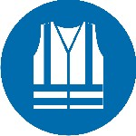 |  |  |  |  |  |  |  |  |  |  | 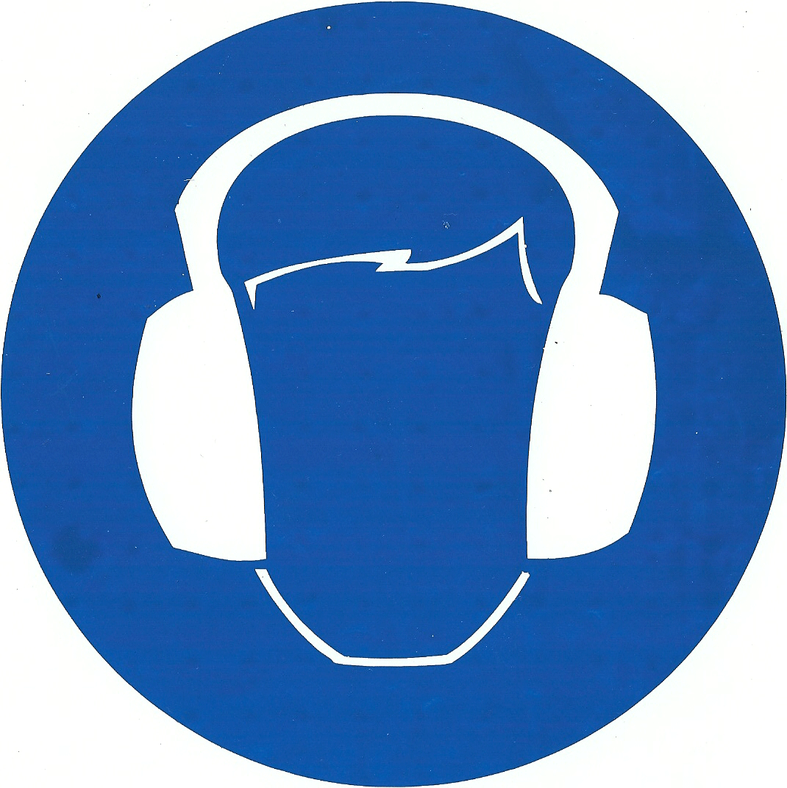 |  |  |  | 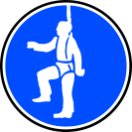 |  |  |  | 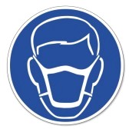
Head  (EN 397) |  | Foot  (BS EN 345-1) |  |  |  | Hi-vis vest (short or long sleeve) |  |  |  | Hand (BS EN 388) |  |  |  | Eye (EN 166) (glasses or goggles) |  |  | Hearing (EN352-1) |  |  |  | Fall arrest |  |  |  | Face mask |  |  |  |  |  |  | Overalls |  |  |  | Other
 |  |  |  | Name |  |  |  |  |  | Position |  |  |  |  |  |  |  |  |  |  |  |  |  |  |  |  | Signature |  |  |  |  |  |  | Date
Prepared By
Checked By
.
RA Amendment / Additional Risk Identified
Hazard | 1 | 2 | 3 | 4 | 5 | 6 | 7 | 8 | 9
 | Factors of harm |  | Risk  (L x S) | Control measures | Factors of harm |  | Residual risk  (L x S) | Control measures implemented by | Acceptable risk
 | L  (1-5) | S  (1-5) |  |  | L  (1-5) | S  (1-5) |  |  | Yes | No

Appendix for Helpful Links for site supervisory team.

Public Health Authority https://www.publichealth.hscni.net
Hand Washing https://www.nhs.uk/live-well/healthy-body/best-way-to-wash-your-hands/
Face fit masks https://www.hse.gov.uk/news/face-mask-ppe-rpe-coronavirus
Mental Health https://www.mind.org.uk/information-support/coronavirus-and-your-wellbeing
www.hseni.gov.uk/stress
Posters, leaflets https://www.gov.uk/government/publications/guidance-to-employers-and-businesses-about-covid-19
Public Health Advice https://www.publichealth.hscni.net/news/covid-19-coronavirus
Skin surveillance https://www.hse.gov.uk/skin/professional/health-surveillance

